A.O.K. Laptop System Overhaul

Course Project: IS 436 Structured Systems Analysis and Design

Deliverable 1 – “System Request” (D1)

10/03/2019

Team Name: Meticulous Evolution Consulting

Project Sponsor: Library Services Manager, Paula Langley.

Presented By:

|  |  |  |
| --- | --- | --- |
| **NAME** | **POSITION** | **CONTACT** |
| Upen Adhikari | Quality Assurance | [Adh3@umbc.edu](mailto:Adh3@umbc.edu) |
| Omar Al-Hedari | Project Manager | [Omara2@umbc.edu](mailto:Omara2@umbc.edu) |
| Nima Roomi | Lead Developer/Programmer | [nimar1@umbc.edu](mailto:nimar1@umbc.edu) |
| Alex Varghese | Database Administrator | [varghes1@umbc.edu](mailto:varghes1@umbc.edu) |

Table of Contents

**Team Introduction** **2**

Upen Adhikari - Quality Assurance 2

Omar Al-Hedari - Project Manager 2

Nima Roomi - Lead Developer/Programmer 2

Alex Varghese - Database Administrator 2

**System Introduction** **3**

Existing System 3

Circulation Desk Laptop Procedures 3

Existing Issues and Proposed Solutions 4

**System Request - A.O.K. Laptop Overhaul System** **5**

A.) Project Sponsor: 5

B.) Business Need: 5

C.) Business Requirement: 6

D.) Business Value/Feasibility Analysis: 6

Technical Feasibility: 6

Economic Feasibility/Cost-Benefit analysis: 6

Cost-benefit analysis: 7

Organizational Feasibility: 7

E.) Special issues or Constraints: 7

F.) Project Methodology Option: 7

# 

# 

# Team Introduction

### Upen Adhikari - Quality Assurance

I’m Upen, I’m currently pursuing a Bachelor of Science in Information Systems at the University of Maryland, Baltimore County. I have worked in a couple of course projects during the semesters here at UMBC. I have played several roles while working on different course projects as a developer, project manager, system analyst, and a tester. For this specific project, I am responsible for performing various tests to ensure the software created by developers is the best fit for the purpose. In addition, I am closely working with my team members to ensure the quality of software development and deployment.

### Omar Al-Hedari - Project Manager

I’m a current student at the University of Maryland, Baltimore County studying Information Systems for my Bachelors. In the previous semesters for group projects, I’ve taken care of planning and guiding towards the end goal. This attention towards the bigger picture in tandem to the smaller details has resulted in full marks for each project. I plan on applying my previous management experience to maintain the flow of operations/tasks.

### Nima Roomi - Lead Developer/Programmer

Hi, I’m Nima a Senior at the University of Maryland, Baltimore County majoring in Information Systems. I have experience programming from classes and from personal projects. I am competent and experienced in web stack technologies and languages. My focus is currently on front-end web development with React, but I am competent in back-end, specifically Node.js and PHP.

### Alex Varghese - Database Administrator

I am Alex and I am studying at UMBC for a bachelors in Information Systems. My experience in programming and IT comes from multiple information systems and computer science classes. I have experience in programming languages such as C++, Java, and Python. I am also experienced in creating databases using sql developer and have some experience with NoSQL with MongoDB.

# System Introduction

## Existing System

The laptop loan program is a new system for the A.O.K. library. The system aims to provide technology access to students, who either temporarily or permanently don't have access. The laptops are provided for short term loans (4 hours) and long term loans (3 days). UMBC students have varying needs when they use the system. Some students need laptops for an online in-class exam. Some students need specialized software UMBC licenses on school laptops. Some students need a temporary laptop since theirs broke and needs repairs. This system was introduced as part of UMBC’s focus to provide fair and equal access to all at need students. Many students depend on this program and for the program to be swift and reliable.

#### 

#### **Circulation Desk Laptop Procedures**

**Check-Out**

1. Ask patron if they are familiar with program/policies
   1. If not, explain loan period, policies, and fines.
2. Open Laptop cabinet
3. Find appropriate laptop type
   1. If reserved, look for paper slip with student’s name
   2. Else, find a laptop bag without a slip
   3. If no laptop is available, ask patrons to come back at a later time.
4. Open the bag, check for charger and laptop
5. Boot the computer to check for functionality
6. Scan patron’s ID card in ALEPH
7. Check patrons history for existing laptop loan
   1. If a laptop is already loaned, notify patron
   2. Check for any large fines/blocks
8. Scan the laptop
9. Scan the charger
10. Put the charger and laptop in the bag
11. Hand the bag to the patron

**Check-In**

1. Ask patron if all items are present
2. Check bag for charger and laptop
3. Inspect charger for any damages
4. Inspect laptop for serious physical damage
   1. If damaged, **don’t check in**. Notify appropriate staff member
5. Boot laptop and check for basic keyboard and mouse functionality
6. Check in charger and laptop within ALEPH
7. Print next patron’s hold request slip if needed
8. Place slip on bag, write expiration time 5 hours from current time
9. Place bag within the laptop cabinet

## 

## Existing Issues and Proposed Solutions

The laptop loan program is facing issuing regarding efficiency and reliability. Laptop loaning procedure/policy is inefficient which results in laptops being unused. Laptops can be loaned from the Circulation Desk at the A.O.K. library but patrons usually come in bursts of high demand rather than equally spaced. The circulation department added an online queue to alleviate these issues. However, the website is extremely confusing to use and unresponsive to changes. The patron is only given limited information such as, when the request was placed, and when it is time to pick up. The patron cannot check their position nor remove themselves from the list, without manually calling. The laptop loan program has been a huge hassle for the department. A laptop checked out is expected to be returned in equal or similar conditions. Nevertheless, laptops are frequently returned damaged. The software used to check out and return books is called ALEPH. ALEPH is an integrated library system for the management, loaning, and automation of library services. Unsurprisingly, this system was not designed or intended to be used for anything other than books and DVDs. So, currently, the library has no proper way to log damages, repairs, and changes for the laptop inventory. The current procedure is to fill out a repair request using a paper sheet, writing down any damages. This system is ineffective since patrons have complained that “they did not damage the laptop” and the library has no photos or concrete evidence to back up any claim. With our proposed system we will implement additional software to interface with ALEPH to provide proper logging, queueing, and loaning support. This software will be intuitive so it is easy to use for patron and will also reduce departmental strain. It will also increase patron accountability and will reduce laptop repair and maintenance costs.

# System Request - A.O.K. Laptop Overhaul System

## A.) Project Sponsor:

Our sponsor is Library Services Manager, Paula Langley she provided us with appropriate information for analysis and subsequently this request. We approached her with the intent of improving efficiency within the library’s circulation department. We discussed several aspects, roles, and processes of the circulation department. As we discussed potential areas of improvement the focus gradually shifted towards the patron side. The manager taught us about the relatively new laptop loan program. The program had undergone many iterations, due to some persistent issues. We decided to analyze the existing and previous system’s issues and address them. The manager will be our sponsor providing us with access to appropriate resources such as system access, specialized and knowledgeable personnel, and an appropriate budget.

## B.) Business Need:

The new system offers an effective and efficient customer service. For example, during rush hour periods it will help to speed up the checkout process and reduce the wait time in the period taken to do so. The features such as online queue-dequeue, push notifications will result in more natural varying checkout times that would be beneficial during the rush hour period. It will boost employee morale by having a structured automated tasks, reducing stress along with confusion that the employee encounters to follow library procedures. Similarly, it will reduce angry patrons along with reducing frequently asked questions that usually comes with annoyance in the process of loaning laptops. The benefits of tracking would increase patrons liability along with the possibility of decreasing the repair frequency costs. The efficient system would also push laptop usage, provides important analytical data, and make efficient use of its resources to its own students. The system will provide detailed information about the lending process assisting in the proper logging, queueing, and the loaning support. Additionally, the mandatory photo attachment feature of the new system will reduce the damage repair costs along with the maintenance cost. The built-in tracking system will provide current status updates with accurate information to users that will help resolve issues for both the patron and the library. These changes will boost UMBC position on inclusivity by diligently providing technology access to students who need it.

## C.) Business Requirement:

The Albin O. Kuhn Library has a fairly small budget. They need these changes in order to reduce their long term costs. Similarly, since the budget is tight, the solution must be economical and appropriate to implement. The library is host to several legacy systems, such as ALEPH. The new system must integrate when needed to legacy systems and ensure compatibility. New systems must have minimal costs with respect to hardware. The library’s IT department is understaffed and overworked, so new hardware must be easy to manage. Hardware must be approved by Sheffield, Carolyn Associate Director, Library Technology & Digital Strategies to ensure proper resource allocation and training.

## D.) Business Value/Feasibility Analysis:

### Technical Feasibility:

There are some risks that could occur when implementing this system, such as user familiarity with technology. For example, because ALEPH does not store pictures, we would have to implement an additional system to be able to store the pictures of laptops to check for damages. This change can cause confusion with the library employees, but we can fix this issue by requiring a seminar for all employees to familiarize the workers with the new system. Project size: The development team for the app will consist of 2 freelancers, the mobile app will take 6 months to develop, and the new system will be compatible with ALEPH.

### Economic Feasibility/Cost-Benefit analysis:

Tangible:

This system is economically feasible due UMBC is not looking forwards to profit with this service. Loaning laptops to patrons that is a student service that helps those students who don’t have the funds to purchase their own laptops. However, one economic benefit from the laptop loan program offers is that it reduces the necessary work of the administrative and technical staff and will reduce operational costs. Another economic benefit is that with the mobile application, we will be able to track the damages of the laptop with pictures and we will be able to charge the appropriate students who damaged the laptop. With the proposed system we believe that we would be able to cut down some of the miscellaneous expenses such as printing cost, paper, and the storing cost for paper file storage and documents.

Intangible:

The intangible benefits relate to subjective values that the implementation of the proposed system will help in providing effective and efficient customer service by avoiding operational inefficiencies in the lending process to the patron. It will boost employee morale,increasing the practice of goodwill among the employees of the library. The implementation of the new system will be environmentally friendly due to the consumption of less paper in comparison to the previous system.

### Cost-benefit analysis:

*See Excel Sheet in GitHub

### Organizational Feasibility:

The goal of the proposed system is to address existing issues of the UMBC Laptop loaning issue. This system will reduce the cluster of work and inconvenience caused by the previous system for both the library and the patron. The Library manager would really appreciate the idea of the system once it is initiated. Especially, when approaching the employees of the library, the thrill of the new system implementation is heard by their response due to it saving time along with energy in the process of lending out a laptop to a patron.

In addition, the library has more than enough space to accommodate hardware devices so there is no need for any organizational structure. Furthermore, the implementation of the system can be done on existing hardware devices of the library. The new system is much easier to handle along with operate due to it being user-friendly with current library employees not causing any confusion on how to use the system. Post-implementation phase of the system would help in the reduction of organizational workforce.

## E.) Special issues or Constraints:

This proposed system could face scalability and interfacing problems while integrating it with myUMBC website due to the site being able to be accessed from different departments on campus.

## F.) Project Methodology Option:

We have chosen **Agile methodology** to design and implement our project due to Agile methodology will always give an opportunity to learn with each iteration and also will be the best fit if we had to address the changing requirements. It allows us to work through prototype and improve it with every cycle following the specific guidelines from the stakeholders during the development phase. We learnt from the class that Agile is flexible along with it increases the productivity of any team. As our development begins we can get rapid feedback from each version and move forward by implementing it. As we have clearly listed the business need and requirement for our project, we can prioritize the features to be implemented and work in general to deliver the project on time.

**Detailed project work Plan with estimation dates:**

***Schedule***

**Figure 1.2 Detailed project work Plan**

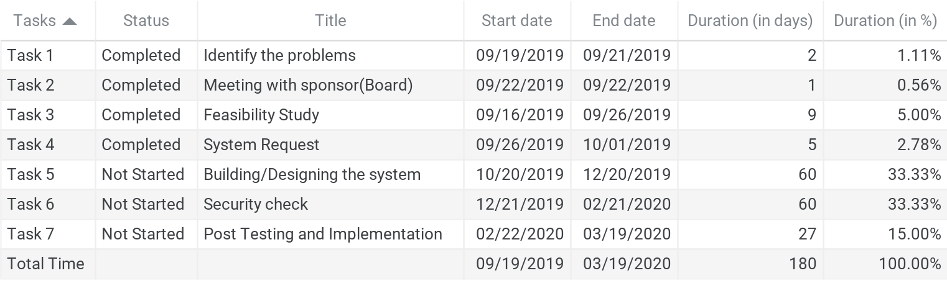

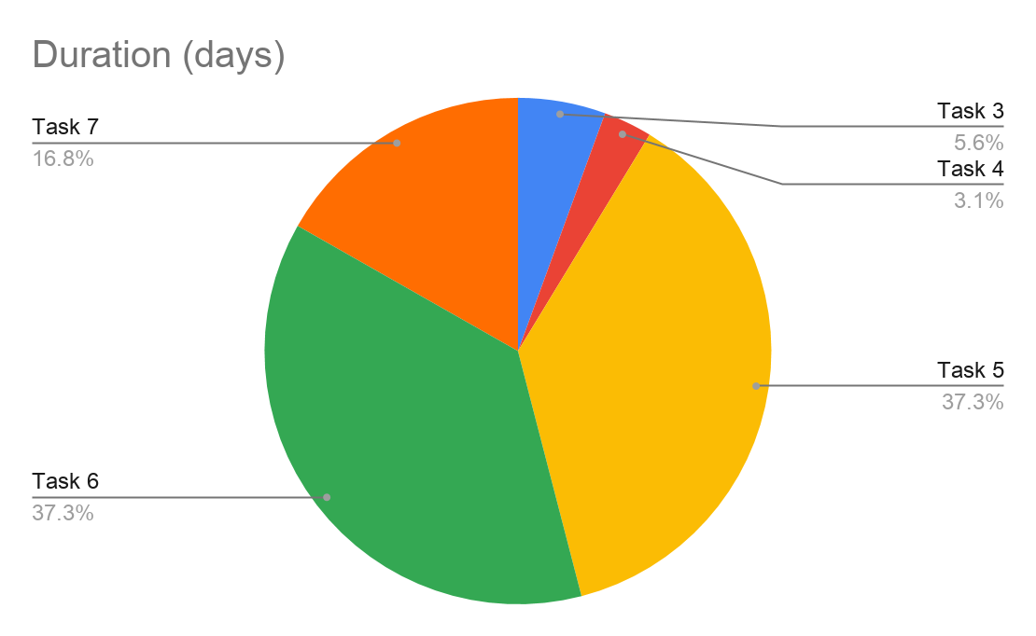

Fig. 1.3. Work Plan

